Oxford School - Grade 6 Supply List 2023- 2024

40 pre-sharpened pencils
2 white erasers
1 pencil sharpener with attached shaving collector
1 large glue stick
1 roll of clear tape
1 highlighter
1 pair of scissors
1 ruler
1 package of washable markers and/or colored pencils
1 package of 8-tab binder dividers
1 package of 200 sheets loose leaf
2-32 page scribblers
2-80 page scribblers
1 durable pocket folder
1 pencil box
1 plastic protractor
2 blue pens
1 zip up large binder (five star brand for example) -this can be reused for Junior High
1 Water Bottle to stay at school

Optional :
-1 clipboard
-1 box of tissues

Grade 5 School Supply List 2023 - 2024

40 pencils
2 Pencil Sharpeners
6 Vinyl Erasers
6 White Board Markers
1 White Board
White Board Eraser (felt works great)
1 Ruler (Canadian measurements cm/mm)
1 Pair of Scissors
24 pk Pencil Crayons
24 pk Markers
1 pencil box preferably the longer one
1 inch Binder
4 Duo tangs with pockets
2 – 80 page non coiled Hilroy
2 Sketchbooks
2 Large roll of packing tape - STEM Projects
1 Water Bottle to stay at school

Optional:

As many Kleenex boxes as you can! And to replenish as the year progresses.

We have very limited space to store all of our supplies.
Please understand that any unnecessary supplies will be sent back home.

Oxford School - Grade 4 School Supply List 2023 -2024

40 good quality pencils
4 large glue sticks
30 cm ruler (Canadian measurement mm/cm)
1 small pencil sharpener with cover
4 erasers (white)
1 Calculator (basic model)
24 pk colored pencils
1 Pencil Case/Box
2 Highlighters
24 pk Markers
3 Permanent Markers (fine tip)
1 White Board
4 White Board Markers
1 Pair of Scissors
2 – 80 page scribblers (no coil)
4 duotangs with pockets (if possible)
8 – 2 Pocket folders
2 Sketch Books
1 Composition Book (hard covered)
1 Pair Headphones
1 Lg Ziplock bag for extra supplies
Indoor shoes for winter (these will remain at school)
1 Water Bottle to stay at school

Optional- Kleenex boxes

Grade 3 School Supply List 2023-24

2 Hilroy (yellow cover) 72 page ½ plain - ½ ruled exercise book (journal)
3 Hilroy (red cover) 72 page ruled exercise book (journal)
24 pk Washable markers
24 pk Coloured pencils
8 pocket folders (no designs or pictures on cover) (without metal tabs)
3 white erasers
4 Low odor dry erase markers
1 bottle of White liquid school glue
3 Glue sticks
Pencil case (no boxes)
40 pre-sharpened HB pencils
Enclosed (screw top) pencil sharpener
1 pair Student scissors
1 package of sticky notes (3” x 3”)
1 Water Bottle to stay at school

Suggested (optional) items:
1 box of Ziplock bags
Tissues (Kleenex)
Spare socks

*School supply list subject to additions in the fall, if necessary.

Grade 2 School Supply List 2023-24

3 Hilroy (yellow cover) 72 page ½ plain - ½ ruled exercise book (journal)
2 Hilroy (red cover) 72 page ruled exercise book (journal)
24 pk Washable markers
24 pk Coloured pencils
8 pocket folders (no designs or pictures on cover) (without metal tabs)
3 White erasers
2 low odor dry erase markers
1 bottle White liquid school glue
3 Glue sticks
1 Pencil case (no boxes)
40 Pre-sharpened HB pencils
Enclosed (screw top) pencil sharpener
1 pair Student scissors
1 Water Bottle to stay at school

Suggested (optional) items:
1 box of Ziplock bags
Tissues (Kleenex)
*School supply list subject to additions in the fall, if necessary

Oxford School - Grade 1 School Supply List 2023-24

2 hilroy excercise books 1/2 lined pages (green)
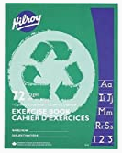
2 pocket folders (red, blue)
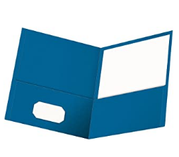
1 Drawing notebook (Dollar Store)
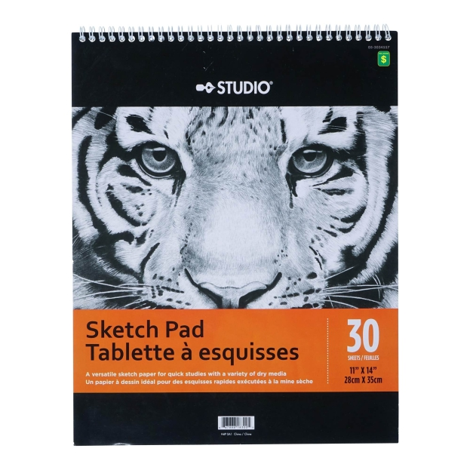
2 packs pencils (24 total)
6 large glue sticks
1 bottle white glue
2 packs crayons (24 pack size)
1 pack washable markers (10 pk)
1 pack coloured pencils (24 pk)
1 black sharpie/ permanent marker
2 white erasers
8 whiteboard markers
1 pair scissors
1 Water Bottle to stay at school

Optional:
Kleenex boxes

